GLOBAL AIR TRANSPORTATION

1.INTRODUCTION:

Air India was sey up by J.R.D.Talta,who ran it successfully until it was nationalized in 1953.In the 1960 the "Maharaja",as the national flag-carrier was affectionately known ,was flying to 32 destinations(it now flies to 46 destinations) and making profits.

1.1.Overview:

The airlines industry encomasses various buisnesses,called airlines,which offer air treansport services for paying customers or buisnes partners.

1.2.Purpose:

Airlines reservation system (ARS)are systems that allow an airline to sell their inventory(seats).

2.Problems statement&Design thinking:

* PROBLEMS: Risky,limitted capacity,accident-prone,requires skill,large invesment
* DESIGN THINKING:Design thinking provides a structured approach to problrem -solving,offering a fesh persective and innovative solutions.

2.1.Empathy Map:

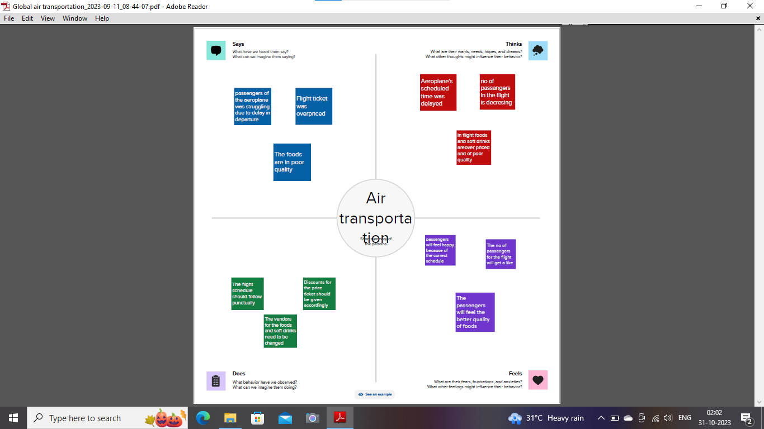

2.2.Ideation and Brainstorming map 

3.Result:The air transport portfolio includes around 26 projects or project components through the international bank for reconstructions and development.

4.Advantages: comfortable and quick service,no physical barriers,easty acces.

Disadvantages:Risky,cost,some producr limitation.

5.Applicatinon:Generate and suort jobs,stregnthen trade and connectivity between people and countries,[romote tourism,and connect remote communities.

6.Conclusion:An airline reservation system is apowerful tool that allows airlines tosell their inventors,manage their shedules and that their passengers.

7.Future Scope: The most recent estimates suggest that demand for air transport will increase by an average of 4.3% per annum over the next 20 years.c